Fruit harvest robot

1. Define the problem the autonomous system will solve.
   1. Strawberries are a very popular fruit that require caution and precision while harvesting to not damage the fruits or pick unripe ones. Norwegian farmers are unable to acquire local workers for the harvest and fly hundreds of workers in from Asia. Would it be possible to design an intelligent UGV for harvesting these berries? Some strawberry plants also require trimming of flowers and runners to make sure the plant doesn’t waste energy that could otherwise be spent growing bigger berries. So, this is another task that could be solved with the same UGV.
2. The context and surroundings of the system (3 qualities, 3 functions)
   1. Surroundings:
      1. There could be plastic covers all around the plants like this: 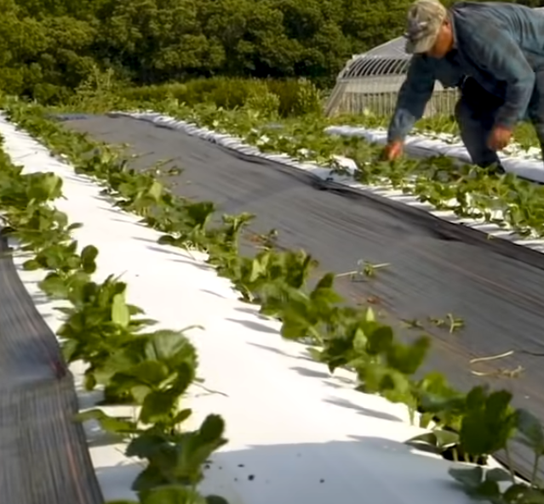
      2. Or there could be straws on the ground

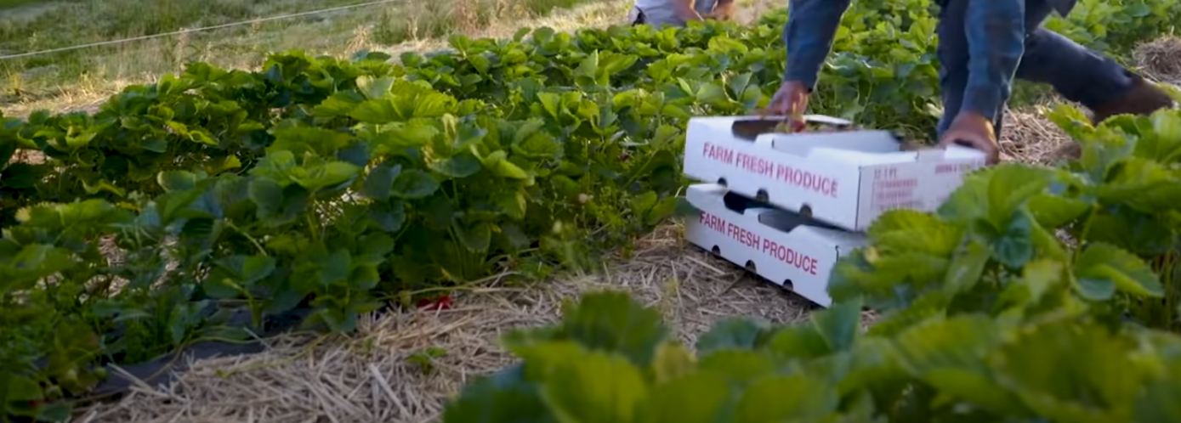

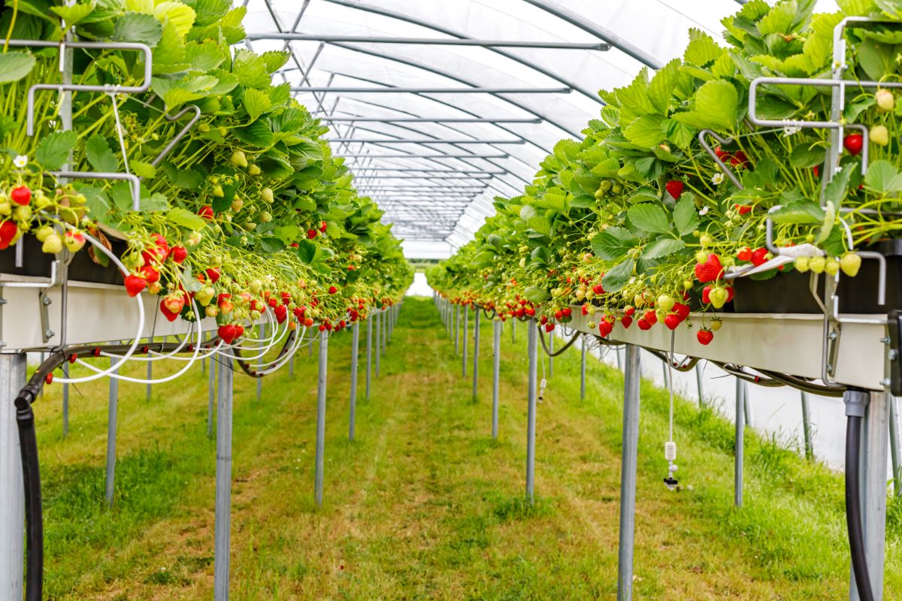

1. Five alternative design solutions for how it will operate

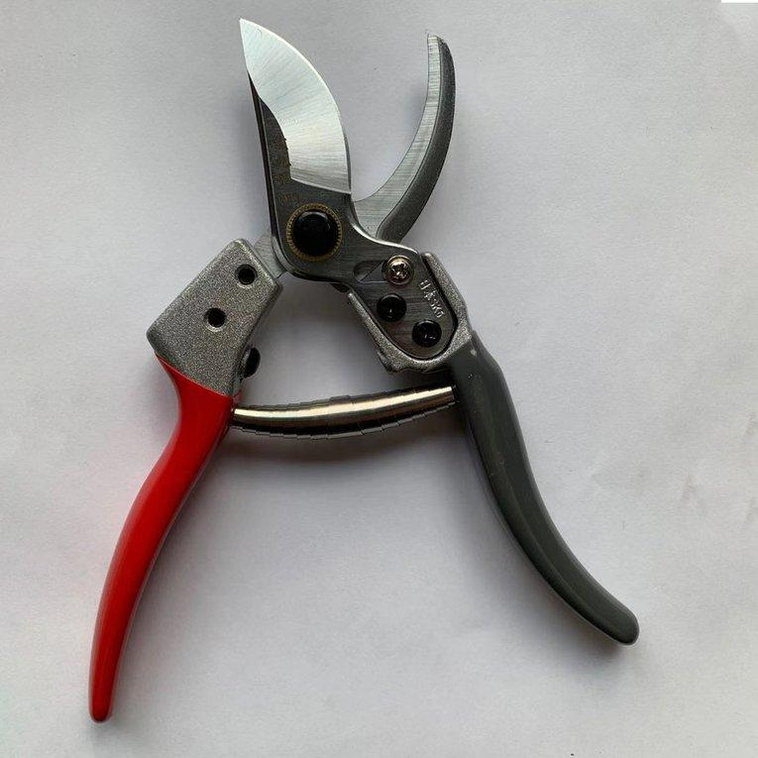

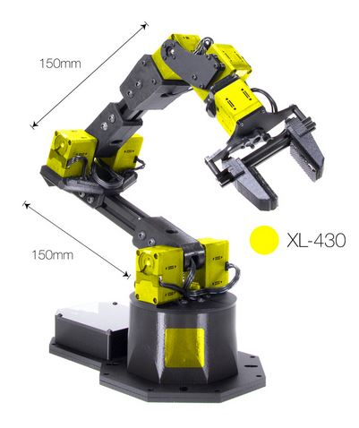

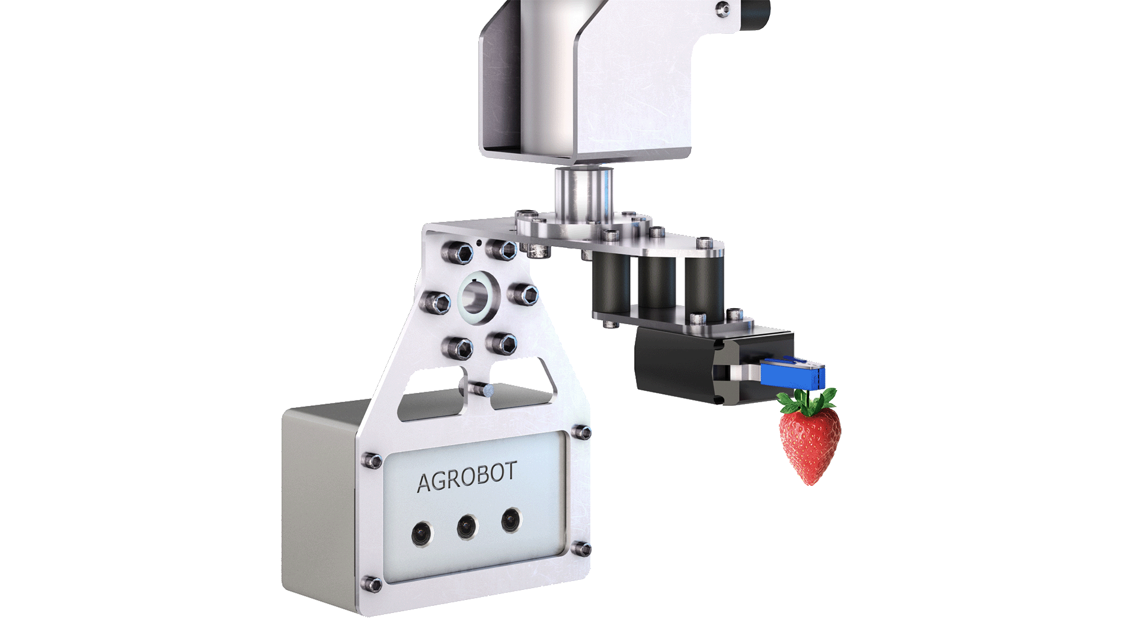

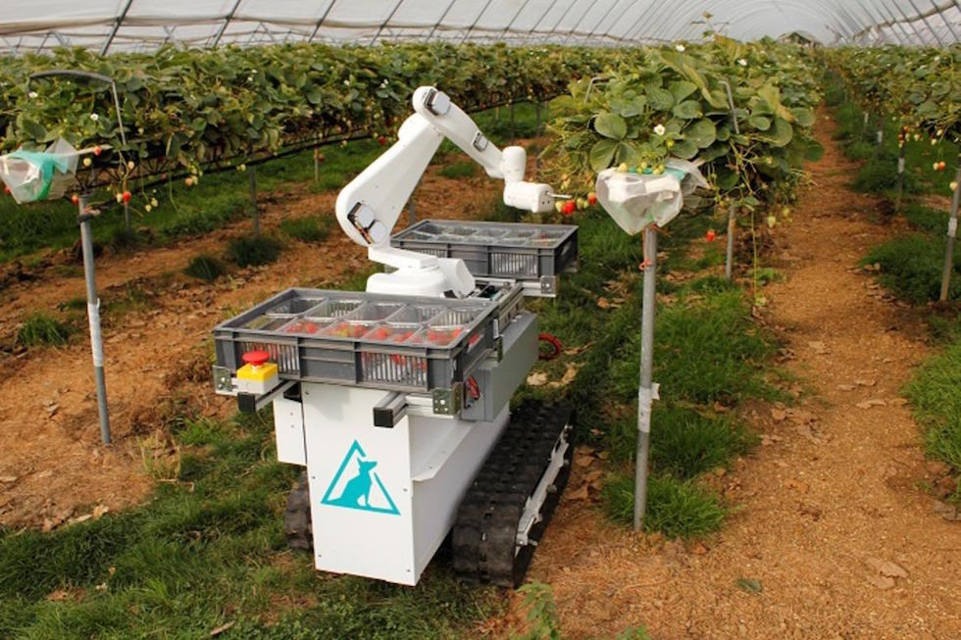

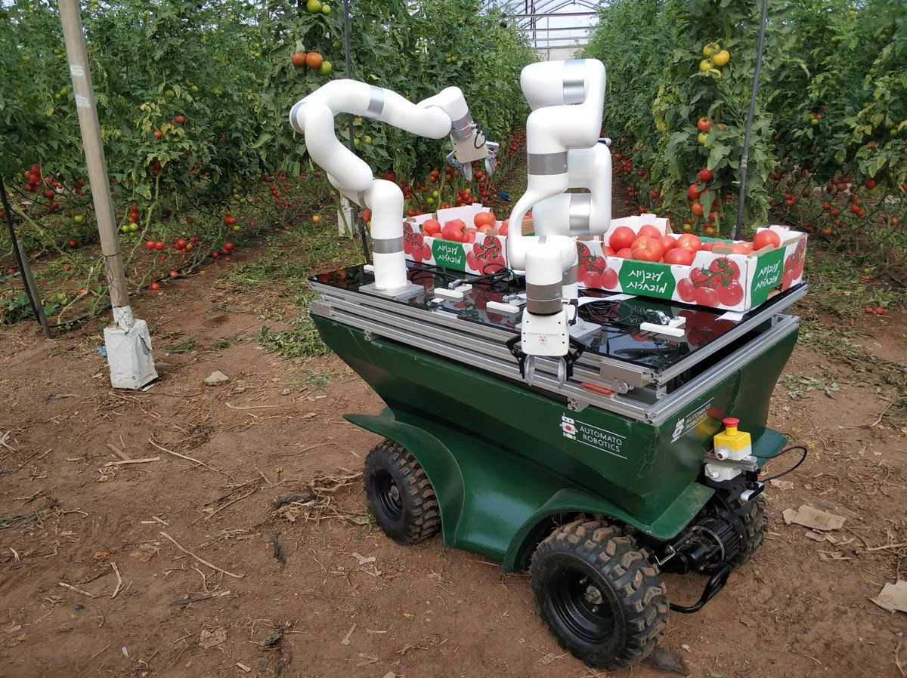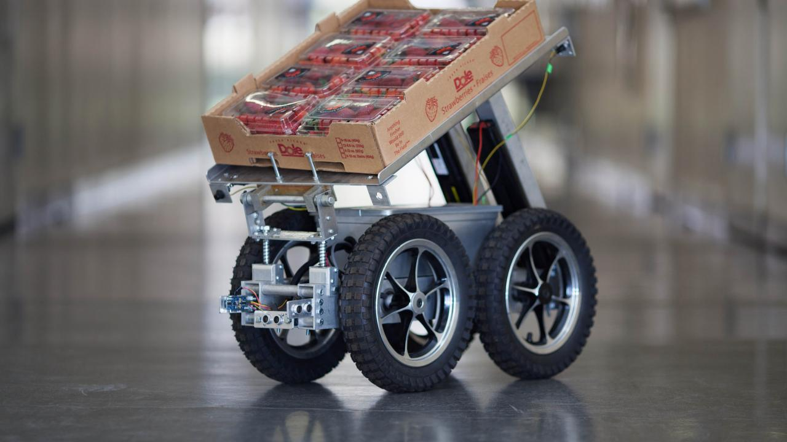

1. The final system – how it works

The picking process:

A robotic arm with some degree of freedom, will be accessorized with a camera and a pincher claw. Using video recognition, the robot will identify ripe strawberries and its stem to calculate and follow the path that gives an acceptably high chance of successfully picking the fruit. The fruit will then be placed in a carried basket.

Traversing the field:

The robot should be equipped with a GPS as well as a speedometer to pinpoint its location at any given time. A degree of configuration would probably be needed to set the boundaries of the farmable fields. Image recognition would again be used to navigate the fields. Initially it would traverse the fields in a linear fashion, e.g., shortest path to check all plants. But after the initial traversal it should remember where the unripe fruit is and plan when and where to go next and get better at this planning as the data set grows over time.

Depositing harvested fruit cases:

During configuration, an area should be picked for harvest drop off. When the robot has fully loaded all its baskets, it will travel to the designated drop off zone, leave the case and equip new one so that it is ready for more harvesting.